***Updating Xstore / Schema Local Vs Store Pre Flight Error***

***Issue:***  
The version of Xstore that is on the register does not match the version of Xstore that is currently applied to the main database. This will cause a Schema Local_VS_Store pre-flight error to show up when attempting to start xstore from that machine.

***Resolution:***

Xstore needs to be updated to match the version of xstore that is currently applied to the database.

**NOTE: You can always deploy the xstore updates with BigFix using the jobs listed below:**Hibbett: "POS - Baseline Install Xstore [UPDATE VERSION] w/ Patch 1.0 w/ Chrome QuickLaunch (HIBB)"  
City Gear: "POS - Baseline Install Xstore [UPDATE VERSION] w/ Patch 1.0 w/ Chrome QuickLaunch (CG)"

If the BigFix job does not deploy appropriately, or it is taking too long, you can manually update Xstore using the instructions below.

First, ensure that the register that has the issue has the correct update files located in the C:\dvinst\xstore\update folder

You can find the appropriate update version by checking the appversion.properties file on the **other register** and seeing what version it states is installed

For example, in this instance, the installed version is 7.1.5.13 - 8.8.0 - 1.0  
**NOTE:** This file is never going to state that a patch is installed, but **ALWAYS** assume the 1.0 patch was installed after the initial version update.  
  
In this instance, the files below are the correct update files that need to be on the register so that we can begin the update.



If these files are not on the register, you can copy them from the other register at the store, or from G:\Helpdesk\Xstore Update Files into C:\dvinst\xstore\update  
**NOTE:** If you have any questions on how to move these files, please reference "using UNC (KB0013564)"

Afterwards, open an elevated command prompt (KB0013562) and type the following  
cd \dvinst\xstore\update  
  
This will take you to the appropriate folder, then you will type the following into the command prompt:  
java -jar xstore

After typing the above, hit **SHIFT+TAB** twice - it will now show the following



It will show the name of the update file - ensure that it is the **update.jar** and not the **patch -**then press enter.

It will now begin the update. You will see the update processing in the cmd window and also notice it extracting files. After it is finished you will see the message below in the cmd window  
 The Total time will vary between each install, but this will let you know the update is finished. The register will then automatically start xstore.

After the update is finished, it will start xstore. After xstore finishes starting back up, you can verify the version of xstore by hitting **Alt+V** at the main screen. If the install finished appropriately you will see the correct version number on this screen.Graphical user interface, application

***CUSTOMIZATIONS:***

**For Hibbett and City Gear locations, they have a few customizations that have to be transferred over to the register after the update is complete**

There are two ways to put these customizations on the register.

First, **make sure xstore is closed**, then, manually move the three folders from the **G:\Helpdesk\xStore Update Files\HB_Customizations_Xstore_v8.8.0-0.33(Chrome Install Required)**folder into the **C:\xstore** folder on the register.

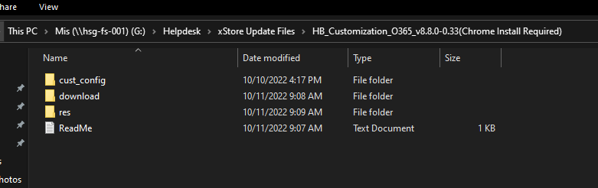It will ask if you want to merge the folders, select "Yes" or "Merge"

After the transfer finishes, you need to run "dataloader2.bat" on the register (make sure you don't accidentally run it while UNC'd into the register).  
Once dataloader is finished, restart xstore.

(Optional) Second, you can deploy the "POS - Deploy "Xstore Custom Configuration" Update QuickLaunch for Chrome (CG)" custom content job in BigFix.  
This will automatically do the first option without any other input from you, but waiting on BigFix jobs to finish can take a while, while manually pushing the customizations is much faster.